Text File Analyzer

Software Requirements Specification (SRS)

Team Members:
Brian Guiley
Robert Tieken
Raul Tapia
Jared Cox
Revision History

Date | Revision | Description | Author
10/13/17 | 1.0 | Flowchart | Brian Guiley
10/16/17 | 1.0 | Initial Version of method starters, Lines/Blank Lines | Robert Tieken
10/23/17 | 1.0 | GUI | Brian Guiley
10/28/17 | 1.0 | Word Method | Raul Tapia
10/29/17 | 1.0 | Spaces Method | Jared Cox
10/30/17 | 2.0 | GUI incorporating Word/Spaces and Character | Brian Guiley
11/12/17 | 2.1 | Add Help/Reset to GUI | Brian Guiley

Table of Contents

- Project Overview 1
  - Overview 1
- Use Cases 2
  - Use Case Diagram 2
  - Use Case Scenarios 2
- Test Plan 3
  - Test Cases 3
- Project Plan 4
  - Plan for the First Deliverable 4
  - Plan for the Second Deliverable 4
  - Plan for the Third Deliverable 4

Project Overview

Overview
The purpose of this program is to Analyze an inputted text file for specific characteristics through a Graphical User Interface developed in Java. The program will keep a record of files analyzed and statistics across files.

Use Cases

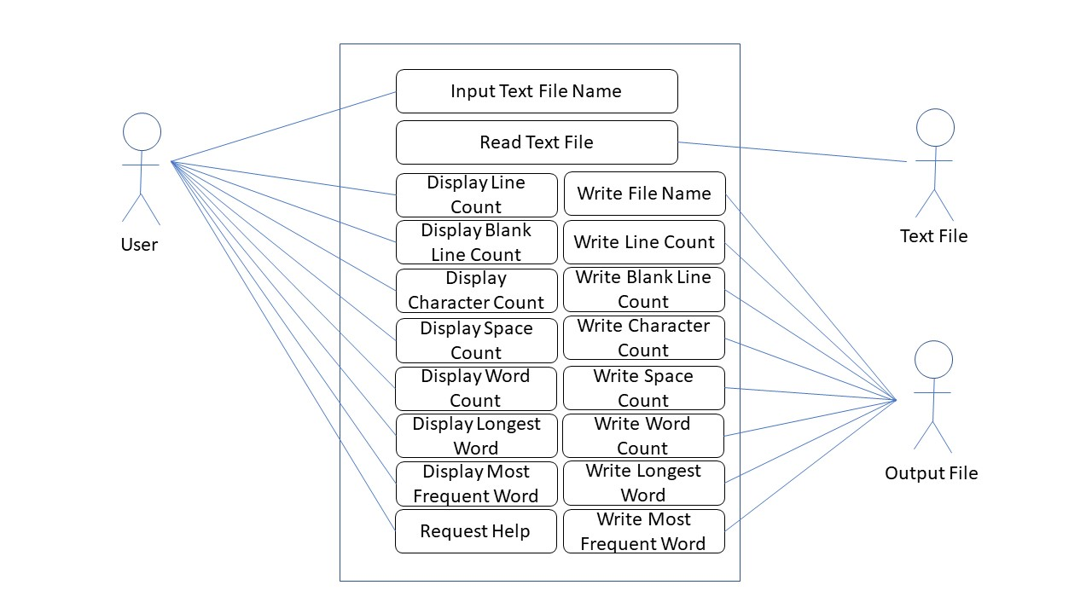
Use Case Diagram

Use Case Scenarios
As a User I will input the text file so that I can analyze it
As a Text File I will provide data to the program to analyze
As an Output File I will receive data to store regarding an analysis of a file.

Test Plan

Test Cases
Specify required behavior of the software product and include parameters such as possible input, expected output, on error, etc.

 | Feature | Description | Possible Input | Expected Output
1 | Upload File | Click on the Browse button and choose a file from directory. | Text File | Success message
2 | Upload File | Click on the Browse button and choose a file from directory. | Binary File | Error message: Only text files are accepted.
3 | …………

Project Plan

Plan for the First Deliverable
Specify the plan for the first deliverable including the list of tasks with a description, assignment of tasks to team members, etc.

 | Task | Description | Assignment
1 | GUI Panel | Development of GUI Panel using Java Swing API in Eclipse. The panel will include text box for file name and analyze button which will initiate analysis | Brian
2 | Lines/Blank Lines count | Methods to count number of lines and number of blank lines in file | Robert
3 | Spaces count | Method to count number of spaces in file | Jared
4 | Word Count | Method to count number of words in file | Raul

Plan for the Second Deliverable
 | Task | Description | Assignment
1 | Class Diagram | Class Diagram of the project will be drawn in Powerpoint. | Brian
2 | GUI Panel | Add Help menu with information and reset options | Brian

Plan for the Third Deliverable

